Build Your Own molecule

There are various software programs and methods available for creating molecular models, such as Gaussview, Materials Studio, Avogadro, Indraw and ChemOffice. Here, we introduce a method for creating D6d (or D6 ) point group molecule using the Indraw software.

1. Open the Indraw software and select Rings -> Benzene from the menu on the left. Click on a blank area, and then save the file as 1.mol format.

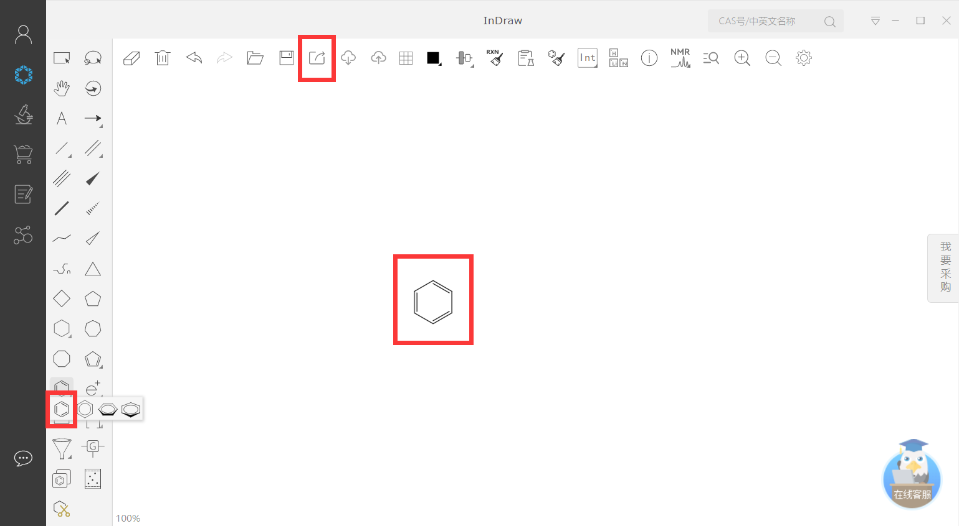

1. Choose Rectangle selection from the menu on the left. Rotate clockwise by 30 degrees at the location of the small circle, and then save the file as 2.mol format.

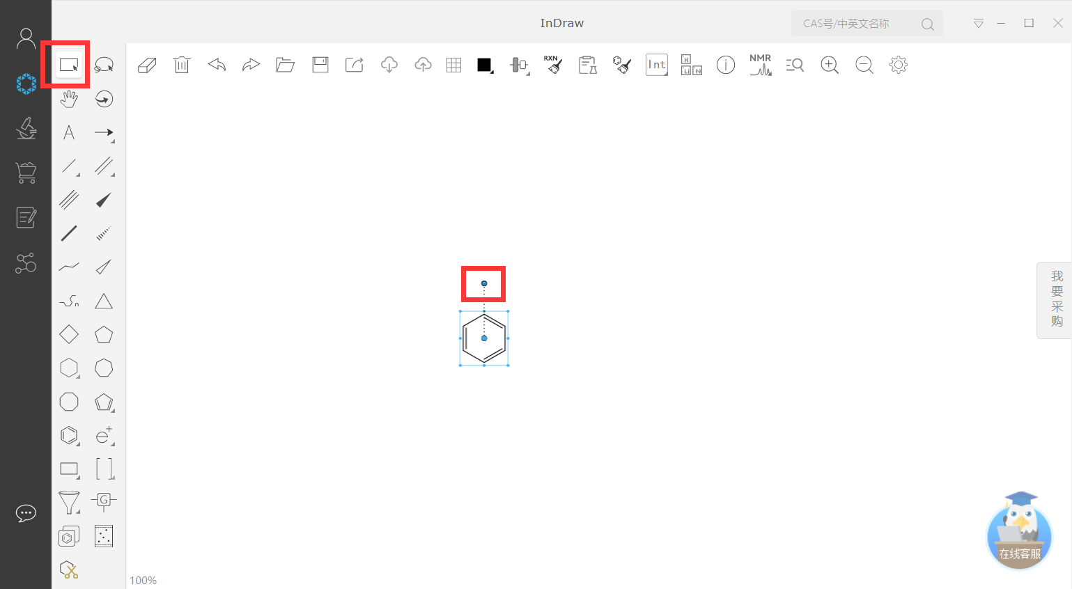

1. Open the file 2.mol using a text editor and change the values in the z-coordinate column from 0.00 to 2.00 (choose a suitable value). Merge the coordinates from 1.mol and 2.mol, and convert them to xyz file format.

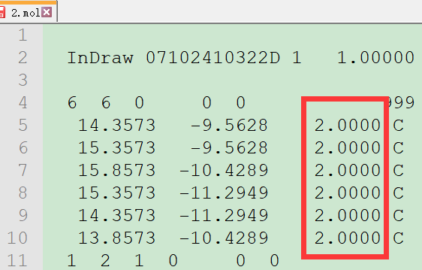

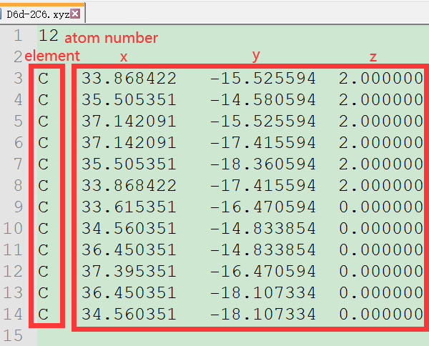

1. By following the instructions in the quick start guide, the new molecule will exhibit D6d point group symmetry.

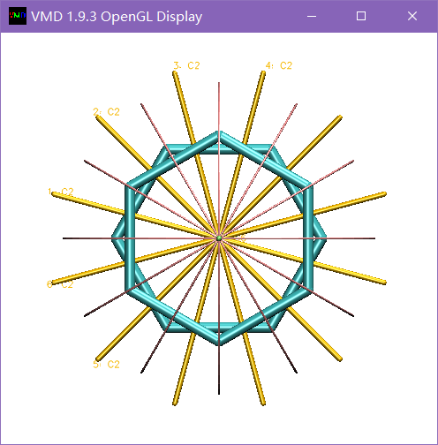

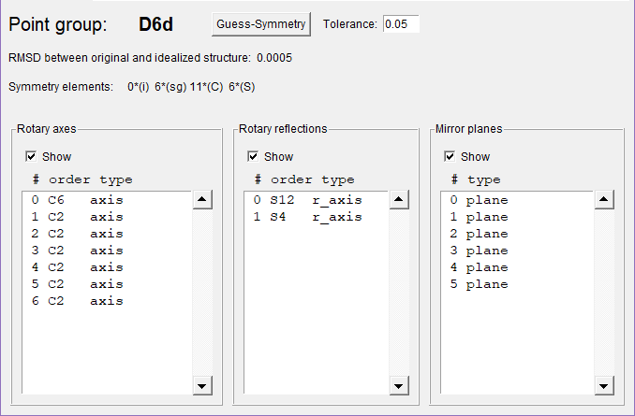

1. To create a D6 molecule, adjust the rotation angle to a different value, such as 10 or 20 degrees, in the second step.